39.68: a) For a standing wave, 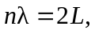and
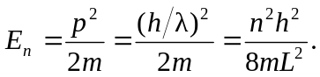
b) With

